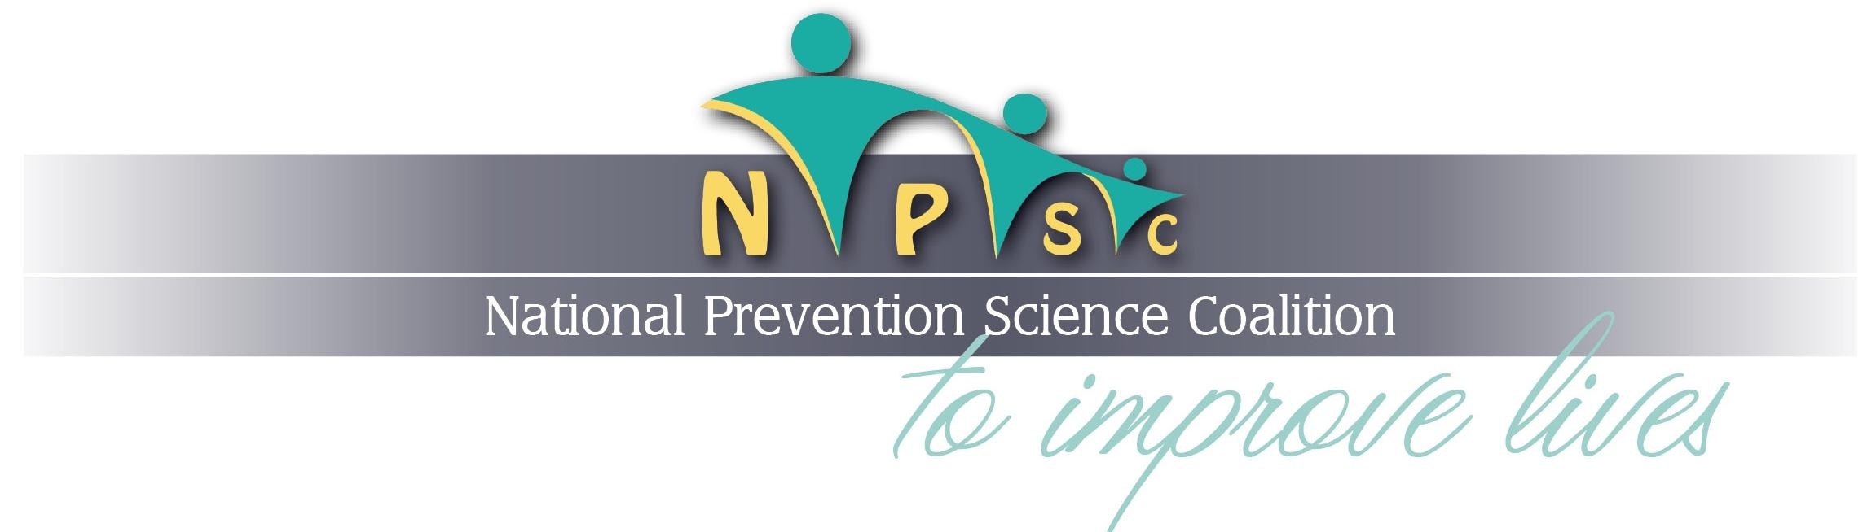WHAT IS PREVENTION SCIENCE?
Prevention science focuses on the development of evidence-based strategies that reduce risk factors and enhance protective factors to improve the health and wellbeing of individuals, families, and communities. Prevention science draws from a diverse range of disciplines—including the epidemiological, social, psychological, behavioral, medical, and neurobiological sciences—to understand the determinants of societal, community and individual level problems (e.g., trauma, poverty, maltreatment). A central tenet of prevention science is the promotion of health equity and reduction of disparities by studying how social, economic and racial inequalities and discrimination influence healthy development and wellbeing. For well over 50 years, prevention science has generated practices and policies that have improved countless lives throughout the lifespan by avoiding negative health and social outcomes (e.g., addiction, academic failure, violence, mental illness) and strengthening conditions that enable individuals, families, and communities to thrive.
The policies, programs, and practices generated by the field have been shown to reduce the incidence and prevalence of individual and community vulnerabilities and to promote healthy lifestyles, including:
- Promoting daily physical activity and good nutrition to protect against chronic disease;
- Disrupting pathways to substance use, abuse and addiction across the lifespan;
- Improving academic and behavioral outcomes with the expansion of high-quality childcare and early learning and development, and promoting positive and supportive school environments;
- Enhancing community-wide capacity to attenuate detrimental conditions and increase access to supportive services;
- Increasing resilience, social competency and self-regulation in order to reduce impulsive, aggressive and off-task behavior; and
- Supporting the development of healthy relationships to reduce interpersonal and domestic violence.
Moreover, evidence-based prevention strategies that address systemic and structural inequalities in neighborhoods, educational, and criminal justice practices have been developed and implemented.
The application of well-tested practices, strategies and policies generated by prevention science can lead to substantial cost-savings by investing in upstream strategies to avoid downstream costs. Examples of these investments include programs that prevent drug use in adolescents, reform educational practices, and support families to reduce the financial and human burden to communities. An integrated delivery system of comprehensive evidence-based prevention strategies that crosses many public sectors (e.g. education, child welfare, juvenile justice, health) is most cost-efficient and exerts wide scale benefits. Providing scientifically-based guidance and resources to legislative and administrative decision-makers will facilitate the integration of best practices from prevention science into policy.
A wide range of effective, well-tested programs and policies are available to achieve these results. Moreover, the field continues to harness the potential for prevention science to improve lives on a population level by further expanding upon the evidence-base. The impact on individual lives, systems (e.g., schools, child welfare), communities, and society can increase exponentially with additional investment of resources and systems to support the development, evaluation, and implementation of evidence-based programs and policies.

Organizational Endorsements:
American Psychological Association
Applied Prevention Science International
Behavioral Health and Research at The University of Texas Medical Branch
Blueprints for Healthy Youth Development, University of Colorado Boulder
Center for Mental Health in Schools & Student/Learning Supports at UCLA
Children's Mental Health Network
Children’s Trust of South Carolina
Child Welfare League of America
Coalition for the Promotion of Behavioral Health
Colorado State University Prevention Research Center
Committee for Children
Families and Public Health Collaborative at Brigham Young University
First Star
Global Alliance for Behavioral Health and Social Justice
Health People
Institute on Violence, Abuse and Trauma
Knowledge Alliance
National Partnership to End Interpersonal Violence Across the Lifespan
Opportunity Nation
Parents as Teachers National Center
PolicyLab
School-Based Health Alliance
Secure Schools Alliance
Society for Child and Family Policy and Practice
Society for Prevention Research
Utah Center for Civic Improvement

